Sunset Lake
Aquatic Vegetation
August 2023

Like most of the relatively shallow lakes in the region, Sunset Lake maintains populations of aquatic vegetation species, all of which are native and beneficial, but if left unchecked can become a nuisance and impede recreational enjoyment of the lake. Although we do not currently have any invasive species, we must be vigilant to ensure they are not introduced to our lake. The Massachusetts Department of Conservation and Recreation estimates that about one-third of the 3,000 lakes and ponds in Massachusetts have been infested with invasive species. Because the waterbodies they infest lack their natural predators, once established invasive species are nearly impossible to eradicate and the cost to manage growth is alarming. If not carefully controlled, invasive aquatic plants can greatly impede boating, fishing, and swimming, and these limitations can negatively impact real estate values.
We perform annual surveys to determine the presence, general abundance, and geographic distribution of aquatic vegetation in the lake to aid in lake management. This report describes the species that have been observed during the vegetation surveys.
While the specific species observed vary from year to year, this is most likely more reflective of survey effectiveness than actual year-to-year variations in species composition. Therefore, it is assumed that any species that has been detected in at least one survey is most likely still present in Sunset Lake, even if it was not detected in subsequent surveys.
Bladderwort
Common bladderwort (Utricularia vulgaris) is the most widespread submerged aquatic vegetation species found in Sunset Lake. Also present are two closely related species, humped bladderwort (U. gibba) and purple bladderwort (U. purpurea). These native, beneficial species are found in many shallow lakes in up to 4-6 feet of water. Bladderwort is consistently found in Sunset Lake’s shallow coves as well as along the shoreline of the main part of the lake.
Bladderworts are long, slender, free-floating plants with branched stems and leaves, with distinctive small bladders in the forks of the leaves (see Figure 1). Common and humped bladderwort flowers, which grow above water, are yellow, two-lipped with a forward-facing spur on the lower lip (see Figure 2). Purple bladderwort flowers are very similar, but as the name would imply, purple (see Figure 3). Flowering occurs between July and August.
Bladderworts are remarkable aquatic carnivorous plants. The bladders are used to capture and digest tiny animals such as insect larvae, aquatic worms, and water fleas. Hairs at the opening of the bladders serve as triggers, and when contacted, mechanically cause the trap to spring open, drawing in water and tiny aquatic organisms like a vacuum. Enzymes and bacteria inside the bladders digest the captured organisms, releasing nutrients for use by the plant.
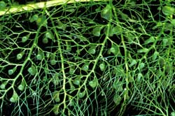
Figure 1. Common Bladderwort
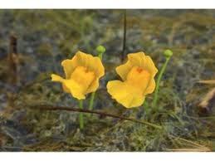
Figure 2. Humped Bladderwort

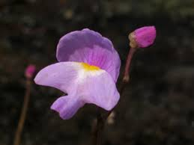
Figure 3. Purple Bladderwort
Bladderworts are native, beneficial plants that offer shade, invertebrate habitat, and foraging opportunities for fish. However, when there is an excess of nutrients in the lake, these plants can form extensive, dense mats that can impair boating, fishing, and swimming.
Low Watermilfoil
There are several water milfoils found in Massachusetts, including Eurasian watermilfoil (Myriophyllum spicatum) and variable milfoil (Myriophyllum heterophyllum), which are invasive species, and the native low watermilfoil (Myriophyllum humile), which is present in Sunset Lake. Low watermilfoil is a submerged aquatic plant (see Figure 4) that looks similar to the invasive milfoil species. Low watermilfoil stems are very leafy. Its leaves are usually in whorls of five, up to 1 inch long with six to ten hair-like segments per side. It is usually found along the shorelines of lakes and ponds. Although it looks similar to the invasive milfoils (which are currently not found in Sunset Lake), low watermilfoil is a native beneficial aquatic plant.
Low watermilfoil has been consistently found in the cove north and west of Sunset Island and occasionally in the small cove west of Lollipop Beach.
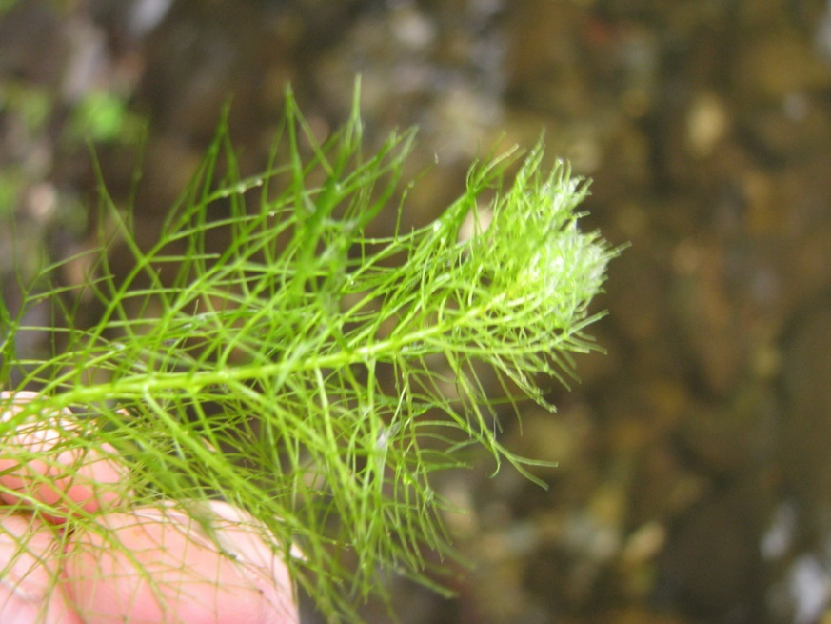
Figure 4. Low Watermilfoil
Watershield
Watershield (Brasenia schreberi) is a rooted aquatic plant that floats on the surface similar to water lilies, but with much smaller leaves. Watershield leaves are typically between 1-2 inches across, oval in shape with smooth edges, usually with a rust-colored underside. The watershield stem is attached to the middle of the leaf. A dull purple flower develops in early summer (see Figure 5).
Watershield is found throughout Sunset Lake, with a prominent stand located in the small cove west of Lollipop Beach.
Watershield is a native, beneficial plant that provides excellent habitat for largemouth bass and sunfish. However, watershield can grow and reproduce rapidly when there is an excess of nutrients in the lake. Dense growth of watershield in shallow areas can interfere with boating and swimming.

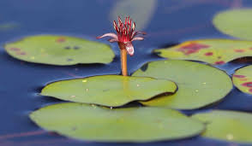
Figure 5. Watershield
Water Starwort
Water starwort (Callitriche palustris) is a native submerged aquatic plant. Its leaves are small and pinnately lobed. Each submerged leaflet is about ½ inch long, with a pointed tip and arranged in a dense pattern along the leaf stem (see Figure 6).
Water starworts are annuals that reproduce by seed and stem fragments. Because the plants are adapted to cool water, growth begins early and flowers bloom in early summer. Seeds become mature by mid to late summer. Water starworts can be found along natural shorelines in Sunset Lake.

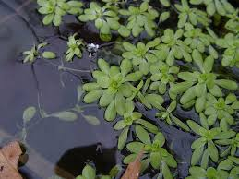
Figure 6. Water Starwort
Water starwort is native and beneficial, and not considered a nuisance species for Sunset Lake. Ducks and other waterfowl eat the leaves and fruit. It also provides protective habitat for fish.
Waterlilies
Waterlilies are common native plants of ponds and shallow lakes throughout North America. They have large, lily-pad leaves that are up to 16 inches across and grow in water up to 10 feet deep. Their leaves and flowers float at the surface, while the rest of the plant is submerged, growing from the sediment at the bottom. Waterlilies flower during the summer, from June to September. Waterlilies are beneficial plants that provide shelter for frogs and early nectar for insects. Left unchecked, however, they can form dense mats that can be a nuisance for boating and swimming.
Two native waterlilies are found in Sunset Lake. The yellow waterlily (Nuphar variegate) has oval, leathery, floating leaves. It has yellow, cupped flowers that are borne on stalks just above the water (see Figure 7). It is usually found in shallower water than the white waterlily (Nymphaea odorata), which has rounder leaves and a larger, whiter flower (see Figure 8).

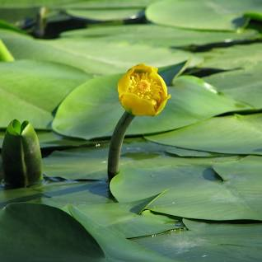
Figure 7. Yellow Waterlily
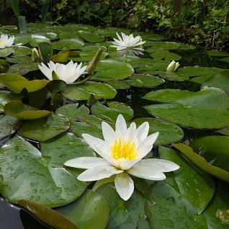
Figure 8. White Waterlily
Slender Pondweeds
Thin-leaf pondweed (Potamogeton pusillus) (see Figure 9) and leafy pondweed (P. foliosus) (see Figure 10), collectively referred to as slender pondweeds, have long, thin, grass-like leaves along slender, branching stems. These pondweeds thrive in deeper, darker water and are consistently found in soft sediments in water depths up to about 10 feet.
Found in most of the shallow coves in Sunset Lake, slender pondweeds are a native and beneficial plant, providing an important food source for a variety of waterfowl as well as food and cover for fish. Deer, beaver, and moose are all known to feed upon this plant.

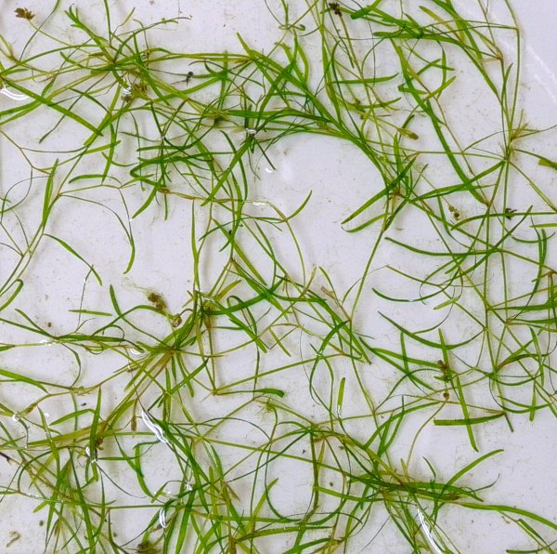
Figure 9. Thin-leaf Pondweed
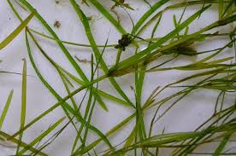
Figure 10. Leafy Pondweed
Stonewort
Stoneworts (Nitella spp.) are macro algae that resemble higher plants (see Figure 11). Their stems are composed of chains of single tube-shaped cells. Instead of true roots, they have a simple rhizoid structure. Stoneworts have slender "branches" of cells arranged in whorls along the main stem.
Found in most of the shallow coves in Sunset Lake, stoneworts are natural, beneficial species providing food for waterfowl and insects that in turn become food for fish and other wildlife. The rhizoids on these algae stabilize the bottom sediments. However, with excessive nutrients, stoneworts can reach nuisance levels.

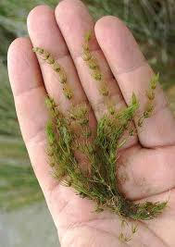
Figure 11. Stonewort

Filamentous Algae
Filamentous algae are single algae cells that form long visible chains, threads, or filaments. When attached to a substrate, such as the lake bottom, submersed or emergent vegetation, or rocks, they are referred to as “benthic filamentous algae.”
Benthic filamentous algae are found throughout Sunset Lake, providing benefits to the lake ecosystem, including stabilizing sediment, acting as a nutrient sink, and providing invertebrate and fish habitat. However, when concentrations of nutrients become too great, benthic filamentous algae can reach lengths of several feet and create a dense carpet on the bottom of the lake. As pieces of benthic filamentous algae break apart, they can form dense mats that float on the surface, called “floating filamentous algae,” more commonly referred to as “pond scum” (see Figure 12). This can obviously become a nuisance in shallow areas such as beaches.

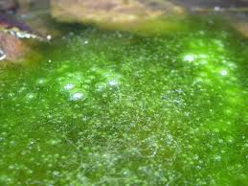
Figure 12. Filamentous Green Algae
Cyanobacteria
Although sometimes called “blue-green algae,” cyanobacteria are not algae, but microscopic bacteria found in freshwater lakes and streams as well as other habitats. Although cyanobacteria are too small to be seen by the naked eye, they can form blooms that are clearly visible (see Figure 13).
Cyanobacterial blooms can lead to a depletion of oxygen in the water and a release of toxins, as well as taste and odor problems. Although cyanobacteria are present in virtually all fresh, brackish, and marine water environments, cyanobacteria blooms have not been detected in Sunset Lake. However, other lakes in our region have experienced cyanobacterial blooms that have necessitated closing the waterbodies to boating, swimming, and fishing for extended periods.

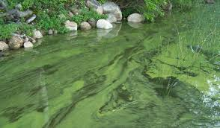
Figure 13. Cyanobacteria Bloom

